LECTURE

Problems of Modern Biology

on the educational program “8D05101 - Biology”
Doctor’s degree 1 year, 1 semester

LECTURE 1
Introduction. History and methodology of biology science.

Aim of the lesson: Acquaintance with the history and methodology of biology science.
Science. Science is a field of research aimed at obtaining new knowledge about nature, society and thinking. Science is a systematic enterprise that builds and organizes knowledge in the form of testable explanations and predictions about the universe. The universe (latin: universus) is all of space and time[a] and their contents, including planets, stars, galaxies, and all other forms of matter and energy.
Research is "creative and systematic work undertaken to increase the stock of knowledge". It involves the collection, organization, and analysis of information to increase understanding of a topic or issue. Research methodology is the specific procedures or techniques used to identify, select, process, and analyze information about a topic. In a research paper, the methodology section allows the reader to critically evaluate a study's overall validity and reliability.
There are many types of research methods. Different methods are used depending on the type of research being pursued. Research methods in science are based on what is known as the scientific method. The scientific method is the basic process that all researchers follow when exploring a specific topic. These methods are important since an individual’s beliefs can influence how she interprets certain phenomena. By using these specific methods, researchers can reduce mistakes based on their own biases or prejudices.
All research methods are based on the scientific method. The scientific method has four primary components. The process begins with a basic observation and description of a phenomenon.
Observations lead researchers to have questions about why certain phenomena occur. Researchers then put forth a hypothesis, or prediction, of what will happen or what the outcome of certain phenomena will be. Researchers then conduct specific types of experiments meant to prove or disprove this prediction.
Research methodology in biology and life science. Life science is one of the major branches of natural science, the other counterpart being the physical science.
Life science or biological science is the scientific study of life and living organisms. Biology falls under the umbrella of natural science discipline and it encompasses various fields such as molecular biology, cell biology, genetics, organismal biology, behaviour health and medicine, neuroscience ecology and evolution. Thus, the research methodology applies to almost all fields in life science and its sub-disciplines.
A good and sound research is based on framing a good research question.
There are numerous ways of research methodology and it relies on the phenomenon being studied. For any type of research, the first ideal step would be to conduct a bibliographical research which is background reading which helps formulate and test the researcher’s hypothesis. The primary source serves as the most reliable research material.
A good and sound research is based on framing a good research question.
There are numerous ways of research methodology and it relies on the phenomenon being studied.
For any type of research, the first ideal step would be to conduct a bibliographical research which is background reading which helps formulate and test the researcher’s hypothesis.
The primary source serves as the most reliable research material.

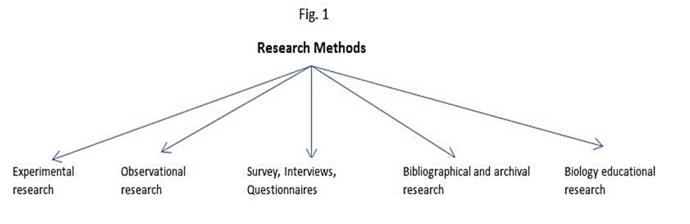

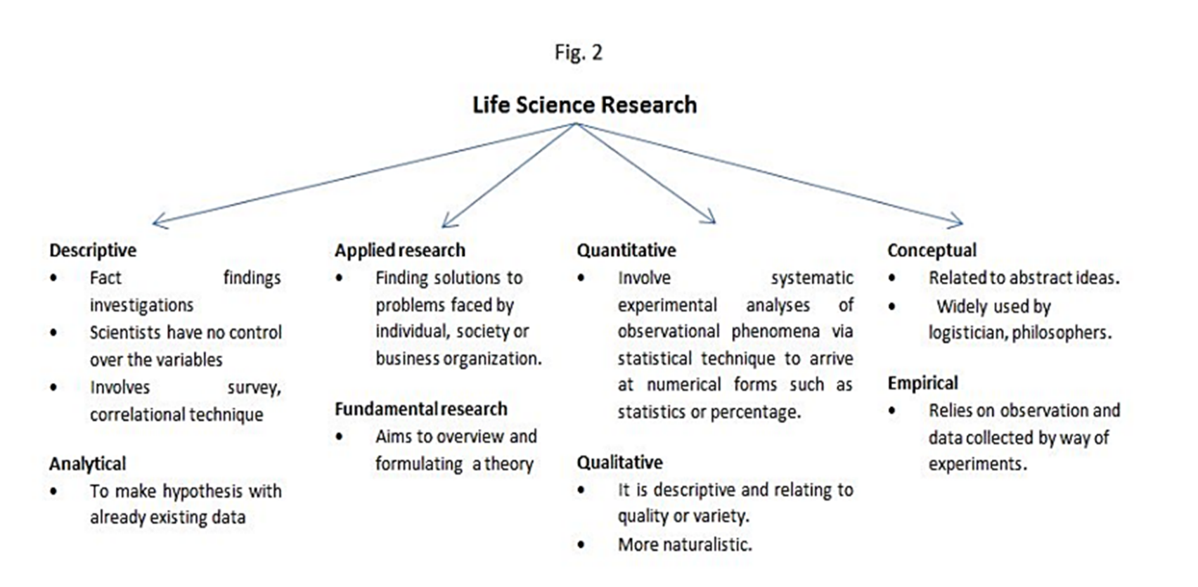

The most widely used methodology in life sciences. Experiments can be conducted in the field or in laboratory. Data may be obtained from cell culture, physiological measurements, biochemical assays, interviews, questionnaires, etc.,
Emphasizes on quantitative rather than qualitative data. It compares two different teaching approaches in school children or students in two different groups.
The following steps highlight the guideline to a researcher in completing his research without any confusion:
1) Identification of research problem
2) Broad literature survey
3) Hypothesis formulation
4) Preparation of research design
5) Determining sample design
It compares two different teaching approaches in school children or students in two different groups.
6) Data collection
7) Analysis of data
8) Hypothesis testing
9) Generalizations and interpretation
10) Preparation of the report or presentation of the results.
A clearly stated research question helps the researcher to formulate a good study design and good study design is the backbone of any successful research.
Control questions:
1. Science and scientific research methods
2. Methods for collecting data
3. Examples of data collection methods
4. Methods for analyzing data
5. Examples of data analysis methods
6. Frequently asked questions about research methods.
7. Research methodology in biology and life science
8. Research methods of biology
9. History of biology science

LECTURE 2
What is the New Biology? Problems of modern biology.

Aim of the lesson: Acquaintance with the problems of modern biology.

Plan of the lesson:
1. What is the New Biology?
2. Who is the new biologist?
3. Problems of modern biology.
What is the New Biology?

In the 1800s, those who studied the living world were called “naturalists” and they were highly interdisciplinary, combining observations from biology, geology, and physics to describe the natural world. In this 200th anniversary year of Darwin’s birth, after decades of highly productive specialization, the study of life is again becoming more interdisciplinary, by necessity combining previously disparate fields to create a “New Biology.”
The essence of the New Biology is re-integration of the subdisciplines of biology, along with greater integration with the physical and computational sciences, mathematics, and engineering in order to devise new approaches that tackle traditional and systems level questions in new, interdisciplinary, and especially, quantitative ways (Figure 2.1).

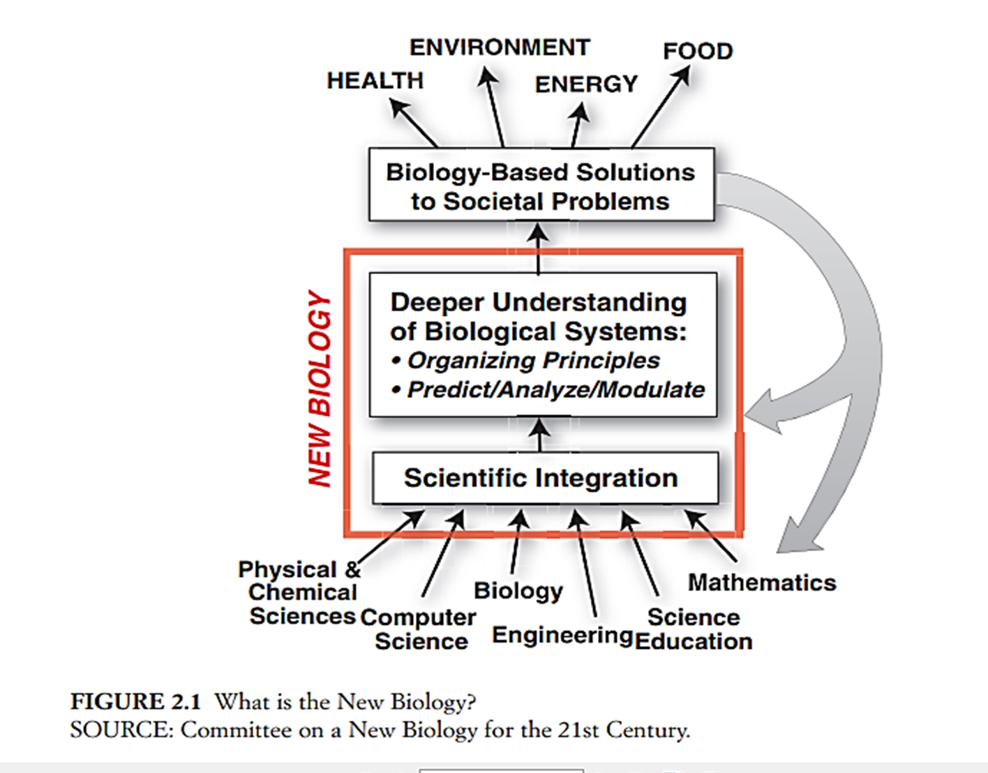

As illustrated in Figure 2.1, the New Biology relies on integrating knowledge from many disciplines to derive deeper understanding of biological systems. That deeper understanding both allows the development of biology-based solutions for societal problems and also feeds back to enrich the individual scientific disciplines that contributed to the new insights.
It is critically important to recognize that the New Biology does not replace the research that is going on now; that research is the foundation on which the New Biology rests and on which it will continue to rely.
WHO IS THE NEW BIOLOGIST? Every biologist who reads this description of the New Biologist will recognize him or herself. All biologists think across levels of biological complexity—molecular biologists consider the impact of genetic regulatory pathways on the health of organisms, Ecologists consider the impact of environmental change on the gene pool of an ecosystem, neuroscientists link cell-to-cell communication with behavior. And an increasing fraction of biologists collaborate closely with physical scientists, computational scientists or engineers.
PROBLEMS OF MODERN BIOLOGY. Nowadays, biologists are faced with many tasks, the solution of which can have a driving influence both on natural science and on the progress of humanity. Among them are questions that are studied by genetics, molecular biology, physiology and biochemistry of muscles, glands, nervous system and sensory organs (processes of memory, excitation and inhibition in the NS); photo- and chemosynthesis, energy and productivity of natural complexes and the biosphere as a whole, the form and content of natural processes, their integrity and expediency, progress, etc.
Taken as a whole, biology as a science is interested in three main problems:
1) mechanisms of the origin of life (there is no single concept);
2) variability (there is no single view of its mechanisms);
3) evolution (the role of the mechanisms of variability in the evolutionary process).
Everything else is covered by these three global problems, and whatever is explored will be the answer to the above questions.
If we consider in more detail, then the main problems of modern biology are:
1) The structure and functions of macromolecules.
It is known that biologically important macromolecules have a polymeric structure (they consist of many homogeneous units, which, however, are not the same). Proteins are formed by 20 types of essential amino acids, nucleic acids contain four types of nucleotides, polysaccharides - a complex of monosaccharides.
In the future, one of the key problems of modern biology is the study of the structure of macromolecules and the elucidation of its influence on their complex diverse functions.
2) Regulation of cell functions (the mechanism of turning on genes at the molecular level; regulation of processes in cells, tissues and organs in order to maintain the relative stability of the system even under changing environmental conditions). Regulation of intracellular processes can be achieved by changing the set and intensity of synthesis of structural and enzymatic proteins, by influencing their enzymatic activity, and by changing the rate of transport of substances through the cell membrane and other biological membranes. In the first place for study in molecular biology is the molecular mechanism of turning on genes (especially in multicellular organisms).
3) Individual development of organisms (clarification of the mechanisms of differentiation at all stages from protein synthesis to the appearance of specific cell properties, cell restructuring leading to the formation of organs; creation of a theory of ontogenesis). The life of every organism that develops sexually begins with a zygote - one fertilized cell (egg), as a result of repeated division of which many cells are formed, each of which contains a nucleus with a certain complete set of chromosomes (contains genes responsible for all the properties and characteristics of a particular organism. However, the development of each cell is different.
Therefore, one of the main problems of developmental biology is the mechanism for turning on genes in the process cell differentiation.
4) Rational organization of human life and development of the problem of life extension.
5) Biological aging (different theories of aging give different reasons why it occurs; the exact cause is not yet known, although there are genetic, mechanical and a number of other theories).
6) The study of the mechanisms of brain activity in order to understand the patterns of thinking and memory processes.
7) The development of organisms on the planet in the course of the history of its existence (disclosure of complex dependencies between adaptations of a fundamental nature acquired in the process of evolution or individual adaptations).
A huge amount of facts confirmed the fundamental correctness of the evolutionary doctrine constructed by Charles Darwin. But still, many of its important provisions have not yet been developed. Therefore, an important task in the near future is to uncover complex dependencies between adaptations of a fundamental nature acquired in the process of evolution, or these are specific adaptations that lead to the development of a certain group (but in connection with the habitat).
8) The origin of life (determining the causes and conditions for the origin of life on Earth, as well as modeling the processes that took place in this case, with the restoration of the successive stages of the arising of life on Earth by the method of experiment).
9) The study of complex physiological and genetic functions of the body (for plants - the genetics of photosynthesis, nitrogen fixation, for animals - behavior, reactions to stress factors).
10) Biosphere and humanity (the study of the biosphere as a dialectical unity of animate and inanimate nature, the most significant point for which is the circulation of matter and energy in nature; the study of the laws of the biosphere to characterize its state in a given period and predict the future of the planet and humanity. The study of the current state and development of promising areas in human economic activity on a planetary scale; a statement of the need to protect and increase wealth in order to maintain a balance in relations between nature and society. The rapid growth of the world's population raises the question of the limits of the biological productivity of the Earth's biosphere. In 100-200 years, while maintaining modern methods of conducting the earth's economy and the same growth rate of the human population, almost half of the people would lack not only food and water, but also oxygen for breathing.
11) The problem of creating sufficient food potential for a growing human population (biotechnology, plant breeding - the creation of fundamentally new forms - more productive, high-quality and resistant to negative factors, with reconstructed genomes and more productive, the creation of transgenic plant species).
12) Biology and technology problems (the study of biological processes and the structure of living organisms in order to obtain new opportunities for solving scientific and technical problems (technical or industrial biochemistry, industrial microbiology); reproduction and modeling of biological processes and individual functions of organisms, as well as designing on basis of such prototypes of new technical systems and devices (problems of bionics).
13) Biology and astronautics (study of the influence of outer space conditions on the body, possible consequences of the action of space factors, the mechanism of adaptation of organisms to the action of space conditions).
14) The development of genetic engineering (genetic reconstruction) (the most urgent task of the modern complex of natural sciences is to predict the long-term consequences of human intervention in natural processes). This task is being solved and will be solved on the basis of in-depth scientific research on the patterns of life phenomena. This is a new and important section of molecular biology, associated with the purposeful construction of new combinations of genes that do not yet exist in nature using genetic and biochemical methods, and one of the most important tasks is to predict the consequences of such construction in the future).
15) Deciphering the genomes of plants, animals and humans (the problem is to understand the processes of differentiation and development of gene sets, the creation of new artificial genomes, the replacement of defective sections of genomes, taking control of gene activity).
Biology can solve the problems facing it at the present stage only in close contact with other sciences: chemistry, physics, cybernetics, and other branches of science and technology. The solution of many issues of modern biology is still in the future.
Control questions:
What is the New Biology?
Who is the new biologist?
Problems of modern biology.

